The Kindle Fire under fire
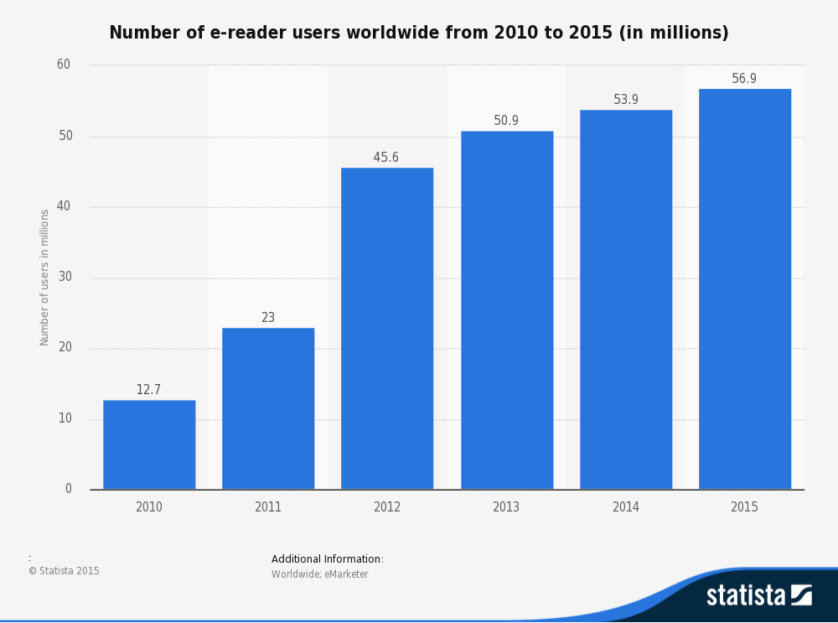
As the graphic above shows, e-readers are highly popular devices across the world (Statista, 2015). I would expect that the number of people who use them would only continue to increase as new technological advancements occur. For this assignment, I used the Kindle Fire HDX 7” tablet to read the book, “The Rocket Book” by Peter Newell. The organization for this paper is as follows: four strengths that apply to e-readers with a brief rationale for each, four weaknesses that apply to e-readers with a brief rationale for each, and a discussion of my personal experience using the Kindle Fire to read my book as it relates to the strengths and weaknesses. I propose that e-readers have as many weaknesses as they do strengths and that the deciding factor is the human interacting with the device who truly determines if the e-reader is usable and valuable.
Strengths of E-readers
Convenience
E-readers offer conveniences that print books do not. They are lightweight, travel friendly and portable. Users can carry around thousands of books all downloaded onto a single device (Entwistle-Clark, 2013; Jabr, 2013; Kozlowski, 2014; Lai & Chang, 2011; MacFadyen, 2011; Richardson & Mahmood, 2012; Wilson, Landoni & Gibb, 2002). E-readers free up space in homes since physical bookshelves are no longer required to store books (Entwistle-Clark, 2013; MacFadyen, 2011; Richardson & Mahmood, 2012), and according to Kozlowski (2014), e-books leave less of a carbon footprint. E-readers also offer reading privacy to their users. People do not need to be ashamed or worry what others will think about risqué reading choices because with e-readers book covers are no longer visible to the public (Kozlowski, 2014; MacFadyen, 2011).
Flexible
Related to convenience, e-readers are flexible. With e-readers, users can stop reading one book and switch to another with the touch of a finger or button (Entwistle-Clark, 2013; Kozlowski, 2014; Lai & Chang, 2011; MacFadyen, 2011; Richardson & Mahmood, 2012; Wilson et al., 2002). E-readers offer cloud-syncing capabilities (Kozlowski, 2014). What this means is that users can start a book on one device and finish on another one all without losing their place. E-readers allow users to buy books from their home; no visits to physical bookstores needed (Kozlowski, 2014), and thanks to OverDrive, users can borrow library e-books from their home at any time of the day or night with their e-reader (Griffey, 2012). Since e-readers can connect wirelessly or over a cellular network, users can quickly download books almost anywhere in the world (Lai & Chang, 2011; MacFadyen, 2011; Richardson & Mahmood, 2012).
Interactive
E-readers are interactive. When reading an e-book, users have the option to write notes, highlight text, create annotations and bookmarks as well as share that content with other readers (Kozlowski, 2014; Lai & Chang, 2011; MacFadyen, 2011; Richardson & Mahmood, 2012; Wilson et al., 2002). In addition, with e-readers, if users do not know the meaning of a word, they can use the built-in dictionary and translation features of e-readers to quickly find out the information without having to leave the e-book. Table of contents, indexes, and text within e-books can be hyperlinked. This allows users to skip around sections as well as be taken to outside sources (Griffey, 2012; Kozlowski, 2014; Lai & Chang, 2011; MacFadyen, 2011; Richardson & Mahmood, 2012).
With Amazon’s Kindle readers and apps, some books offer enhanced content features, such as X-Ray, which allows users to learn more about the characters and key terms in the book, and popular highlights, which allows users to see which passages in the text are most highlighted by other readers (Amazon, 2015b; Kozlowski, 2014). In addition, with e-readers users can search across the entire book for keywords and phrases, which allows them to quickly locate the needed information (Lai & Chang, 2011; MacFadyen, 2011; Richardson & Mahmood, 2012; Wilson et. al, 2002).
Personalization
E-readers allow users to personalize their reading experience, which also helps with providing accessibility. With e-readers, users can change the font size and type, the background color of the book, customize the language of their reader, and adjust the brightness of their screen (Amazon, 2015a; Benedetto, Drai-Zerbib, Pedrotti, Tissier & Baccino, 2013; Kozlowski, 2014; Lai & Chang, 2011; MacFadyen, 2011; Richardson & Mahmood, 2012). An additional personalization feature focused strictly on accessibility is the text-to-speech feature, in which a user can have a book read to them and modify the speed at which it is read. This feature automatically advances pages for the user (Amazon, 2015a).
Weaknesses of E-readers
Fragile
Without a doubt, e-readers are fragile. Screens scratch easily, which interferes with visibility when reading. Devices break when dropped, which renders them unusable. Essentially, the user is left with a very expensive paperweight (Entwistle-Clark, 2013; MacFadyen, 2011; Richardson & Mahmood, 2012; Wilson et al., 2002). The liquid crystal display (LCD) e-readers are also hard to see in direct sunlight (Entwistle-Clark, 2013; MacFadyen, 2011; Richardson & Mahmood, 2012). Bright and sunny days are the enemy of LCD e-readers for those people who want to read outdoors. Print books, on the other hand, are resilient. They can be dropped in the water and still read; they can be run over with a car and still be used (Entwistle-Clark, 2013). They work in any kind of weather and last for years.
Reliance on technology
Related to fragility, e-readers are reliant on technology. If the battery on a user’s e-readers fails, she can no longer read her book (Griffey, 2012; Entwistle-Clark, 2013; Richardson & Mahmood, 2012; Wilson et al., 2002). If the hardware or software inside of the e-reader fails, once again the user is left with an expensive paperweight (Entwistle-Clark, 2013; MacFadyen, 2011; Richardson & Mahmood, 2012; Wilson et al., 2002). Related to that, since e-readers are technology, they have a limited life span. After a few years, due to incompatibilities with future software updates, the user may be required to purchase a newer model (MacFadyen, 2011; Richardson & Mahmood, 2012). In addition, the costs of e-readers can be very expensive depending on their specifications and features (Griffey, 2012; MacFadyen, 2011; Richardson & Mahmood, 2012).
Physical discomfort
E-readers have also been known to cause physical discomfort with users. Reading for prolonged periods on LCD e-readers causes eyestrain, dry eyes, and headaches (Benedetto et al., 2013; Jabr, 2013). Recent research shows that users who read on LCD e-readers blink far fewer times compared to print, which in turn, aggravates visual fatigue (Benedetto et al., 2013). In addition, screen brightness, even when adjusted, can still be too bright and hurt users’ eyes (Benedetto et al., 2013; MacFadyen, 2011; Wilson et al., 2002). Other research shows that reading LCD e-readers at night before attempting to sleep actually inhibits users from falling asleep, from achieving a restful sleep, and disrupts natural circadian rhythms (Guiang, 2014).
Bookless experience
As much as designers try to make them, e-readers do not provide the same reading experience as books. For one thing, it is harder, and sometimes impossible, to lend e-books to other people (MacFadyen, 2011; Richardson & Mahmood, 2012; Wilson et al., 2002). Due to digital rights management (DRM) restrictions, some e-readers will limit sharing of items to other users with the same type of device as well as only read certain types of files (Griffey, 2012; Richardson & Mahmood, 2012). In addition, the content that appears on an e-reader is not really owned by the user (Griffey, 2012; MacFadyen, 2011; Richardson & Mahmood, 2012). Case in point, in 2009, Amazon removed copies of George Orwell’s “1984” from all users’ Kindles along with any annotations and notes (MacFadyen, 2011).
In addition, e-readers fail to provide users an effective “mental map” of the text (Jabr, 2013, para. 10). According to Jabr (2013), users cannot picture what they just read in the text in relation to the entire book. This is because there is no left side, right side to an e-reader. It is just a single page. Wilson et al. (2002) terms this as a lack of “sense of place” (p. 326). Even though e-readers provide page numbers and progress percentages, some users do not consider reading an e-book to be the same reading experience as that of a print book (Entwistle-Clark, 2013; Jabr, 2013; MacFadyen, 2011; Richardson & Mahmood, 2012; Wilson et al., 2002). Research also shows that e-readers encourage skimming, as opposed to reading for comprehension, since it is so easy for readers to swipe to get to the next page as well as search throughout an e-book for the relevant material (Jabr, 2013; MacFadyen, 2011).
Conclusion
E-readers have their pluses and minuses, just like any technology tool. In some situations, print may work best, such as when a reader really wants to delve deep into a text (Jabr, 2013; MacFadyen, 2011; Wilson et al., 2002). In other situations, e-readers may be more convenient, such as when traveling (Entwistle-Clark, 2013; Jabr, 2013; Kozlowski, 2014; Lai & Chang, 2011; MacFadyen, 2011; Richardson & Mahmood, 2012; Wilson et al., 2002). They are not for everyone. Some people will always prefer print; whereas, others eschew print in favor of the newest technology tools. Still, some people will find a happy medium between the two. In my opinion, what it boils down to is if the strengths outweigh the weaknesses for the person at hand.
My E-reading Experience
To search for my book, I used the native Silk app on my Kindle Fire. I went to the International Children’s Digital Library (ICDL) and used the featured books list to find a title that sounded interesting. I decided upon “The Rocket Book” because the description of it said the content included illustrations and rhyming, two pluses in my eyes. I read this book twice. First using the Silk browser with the native ICDL e-reader interface and second using the native Kindle Fire book app. I will discuss both of my experiences in relation to the strengths and weaknesses that applied.
ICDL E-reader Interface
To begin, I had a lot of trouble navigating the ICDL e-reader interface. The buttons were very tiny and appeared in the upper-middle right of the screen. Although the book auto-sized itself to fit my 7” screen, the text was small and I found myself squinting at times to read it. I tried to use the zoom button that appeared in the navigation menu but my fingers kept hitting the wrong button so much that I quickly gave up (MacFadyen, 2011; Richardson & Mahmood, 2012; Wilson et al., 2002). Purely by accident, I discovered that if I touched the text a box appeared around it that enlarged the text but there were no indications to do so. If I touched the screen outside the text, the page would progress but I could not figure out how to make it go back without using the navigation menu arrows. I tried to swipe as I do with my Kindle app but that did not do anything.
I was pleasantly surprised that the digitized version of the book in the ICDL e-reader interface was in color. This made the illustrations stand out much more versus the expected black and white illustrations. They were lovely and helped make my experience with the ICDL more positive. On a negative note, there were no page numbers or progress bar to indicate where I was in the text and it was very disconcerting to me as a reader to not know how much I had read or how much was remaining (Jabr, 2013; MacFadyen, 2011; Richardson & Mahmood, 2012; Wilson et al., 2002). In addition, there were no options for interactivity. The book did not include a linked table of contents neither could I highlight, make notes, or look up definitions while reading (Griffey, 2012; Kozlowski, 2014; Lai & Chang, 2011; MacFadyen, 2011; Richardson & Mahmood, 2012; Wilson et al., 2002).
While I enjoyed the opportunity to use the ICDL e-reader interface on my Kindle Fire, I do not believe I will be repeating it in the future. If I want to read books through this interface, I will use a larger screen, such as my computer or laptop, where I have the option to use my mouse instead of fingers only.
Kindle Fire native book app
After searching in the Kindle bookstore and downloading a free copy of “The Rocket Book,” I opened the book and found multiple opportunities to interact with the book (Griffey, 2012; Kozlowski, 2014; Lai & Chang, 2011; MacFadyen, 2011; Richardson & Mahmood, 2012; Wilson et al., 2002). The first thing that appeared was an “About this Book” pop out. Within the pop out, I found a brief summary of the book, the typical time it takes to read it, a reader rating, and a short bio about the author. After closing the pop out, I clicked on the side menu and found a hyperlinked table of contents. While reading the book, at the bottom of the screen, I could see page number as well as a progress bar indicating my location in the book. In addition, I could add notations, make bookmarks, highlight parts of the text as well as click on words to see definitions and translations.
I also had options to personalize my reading experience (Benedetto et al., 2013; Kozlowski, 2014; Lai & Chang, 2011; MacFadyen, 2011; Richardson & Mahmood, 2012). I could modify the font type and size, change the background color, and the screen brightness. The Kindle Fire offered the text-to-speech feature, which I used to modify the reading speed and have the pages automatically progress for me (Amazon, 2015a). It also synchronized my reading progress across all of my devices so I did not have to hunt for the last page I read (Amazon, 2015b; Kozlowski, 2014).
On a negative note though, the Kindle version of this book was horrible. There were no illustrations and distracting [pg] notations appeared on each page to indicate where the missing illustrations occurred as well as the print page formatting of the book. I was extremely disappointed with this and had expected some kind of illustrations to appear (MacFadyen, 2011; Richardson & Mahmood, 2012; Wilson et al., 2002).
Both interfaces
From previous experience reading books on the Kindle Fire, I have learned that it is harder for me to fall asleep when I read at night (Guiang, 2014) and that reading for extended periods makes my eyes dry and tired (Benedetto et al., 2013; Jabr, 2013; MacFadyen, 2011; Wilson et al., 2002). Related to that it physically hurts my eyes to read it in the dark (Benedetto et al., 2013; MacFadyen, 2011; Wilson et al., 2002). I can only read my Kindle during the day using natural light in my house or with a lamp. In addition, I do not like reading non-fiction content on my Kindle. I find it hard to concentrate and really process what I am reading (Jabr, 2013; MacFadyen, 2011). With the Kindle Fire, I find it easier to skim that type of content so I can keep swiping the pages.
Conclusion
Based on both of my e-reader experiences, I think that this book would read better in print. I missed being able to touch the illustrations and look at them in more detail, which print allows. Although the colored digitized illustrations were beautiful in the ICDL interface, I think that they lost some of their vivacity. In addition, I imagine that this book would have the “old book smell” that I associate with libraries and I missed flipping back and forth between the pages to see the progression of the rocket (Entwistle-Clark, 2013; Jabr, 2013; MacFadyen, 2011; Richardson & Mahmood, 2012; Wilson et al., 2002). Not being able to touch the book detracted from my overall experience. Some books do not translate as well to digital and ones that have colored illustrations such as this one fall into that category for me.
I do enjoy the convenience and flexibility that my Kindle Fire offers me. I no longer have to lug multiple books around when I travel and I do not need to be embarrassed when reading my trashy romance novels in public. I also really like that I can pick up any of my devices and continue reading my books. Nevertheless, there are still authors that I prefer to buy in print so I can keep the content forever and am not dependent on the whims of my device, e.g. battery life or direct sunlight, when I want to read. Besides that, I still love the feel and texture of a print book. Something about print speaks to my heart. Not to mention that when it comes to academic reading, I still default to paper. For me, print equals deep reading. For the foreseeable future, I plan to continue mixing print with e-books as best suits my mood and needs.
References
Amazon. (2015a). Accessibility for Fire. Amazon.com. Retrieved from
http://www.amazon.com/gp/feature.html?docId=1000632481
Amazon. (2015b). Reading enhancements. Amazon.com. Retrieved from
http://www.amazon.com/gp/help/customer/display.html?nodeId=200729910
Benedetto, S., Drai-Zerbib, V., Pedrotti, M., Tissier, G., & Baccino, T. (2013). E-readers and
visual fatigue. PLOS ONE, 8(12), 1-7. doi:10.1371/journal.pone.0083676
Entwistle-Clark, T. (2013, March 8). Advantages and disadvantages of e-readers. Examiner.com.
Retrieved from http://www.examiner.com/article/advantages-and-disadvantages-of-e-readers
Griffey, J. (2012). E-readers now, e-readers forever! Library Technology Reports, 48(3), 14-20.
Guiang, A. K. A. (2014, December 22). Reading from an e-reader before bedtime disrupts sleep
– study. The Science Times. Retrieved from http://www.sciencetimes.com/articles/2126/20141222/electronic-devices-immensely-disrupt-sleep-chemistry.htm
Jabr, F. (2013). Why the brain prefers paper. Scientific American, 309(5), 48-53.
Lai, J. Y., & Chang, C. Y. (2011). User attitudes toward dedicated e-book readers for
reading. Online Information Review, 35, 558-580. doi:http://dx.doi.org/10.1108/14684521111161936
Kozlowski, M. (2014, October 26). eBooks vs print – the reasons why digital is better. Good
eReader [Blog]. Retrieved from http://goodereader.com/blog/electronic-readers/the-main-reasons-why-ebooks-are-better-than-print
MacFadyen, H. (2011). The reader’s devices: The affordances of eBook readers. Dalhousie
Journal of Interdisciplinary Management, 7(1), 1-15.
Richardson, J. V., & Mahmood, K. (2012). eBook readers: User satisfaction and usability issues.
Library Hi Tech, 30, 170-185. doi:http://dx.doi.org/10.1108/07378831211213283
Statista. (2015). Number of e-reader users worldwide from 2010 to 2015 (in millions) [eMarketer
data]. Retrieved from http://www.statista.com/statistics/249807/number-of-e-reader-users-worldwide/
Wilson, R., Landoni, M., & Gibb, F. (2002). A user-centred approach to e-book design. The
Electronic Library, 20, 322-330. doi:10.1108/02640470210438865

